Italy wakes up to the realities of immigration
Riots and street killings concentrate Italian minds
Tom Kington in Rome The Observer, Sunday 21 February 2010
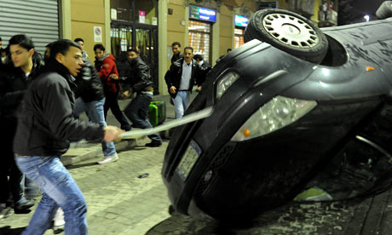
Rioting in Milan after the death of an Egyptian man allegedly killed by South Americans. Photograph: MILO SCIAKY/EPA
In the space of a few weeks, Italy has witnessed bouts of violence involving immigrants that seem to be lifted straight from Hollywood films, starting with Mississippi Burning replayed in Calabria last month and, on the streets of Milan last week, West Side Story.
After hundreds of African fruit pickers were hauled out of Rosarno in Calabria in January following battles with locals, an Egyptian man was left dying in Milan after a fight between North Africans and Latin Americans.
The death of Ahmed Aziz El Saied, 19, was followed by hours of rioting by North Africans on Milan's multi-ethnic Via Padova, during which 36 cars were damaged or overturned and five businesses, mostly run by South Americans, were destroyed.
"I'm not surprised, there are brawls here every day," said a neighbour of Saied. Amid calls by Northern League politicians for round-ups of illegal immigrants and a ban on house sales to non-Europeans, Italy's first inter-ethnic-minority riots woke the country to Milan's hidden world of South American gangs with names such as the Latin Kings.
Statistics show immigrants total 4.3 million, 7.1% of Italy's population, with 45% of young Italians opposed to immigration. But government ministers from the Northern League took a surprisingly soft line.
League founder Umberto Bossi, who once said migrants arriving from Africa should be shot at, said "jobs and homes" were key to avoiding violence.
The involvement of Latinos – rather than Romanians who fill Italy's crime pages – may explain the muted reaction. The Dominican man arrested on suspicion of Thursday's killing was legally registered and dating an Italian woman. Calls within the government for greater integration are growing.
Source: http://www.guardian.co.uk/world/2010/feb/21/italy-milan-race-riots

